Petty Politics – 2 Players

Created by: Jennifer Assid

# Objective of the Game

Be the first player to clear all cards from their three task decks.

# Set-Up

***\*\*\* The board has already been set up for you online. This is here to reference the terms used within the rules and how those translate to the positions on the table\*\*\****

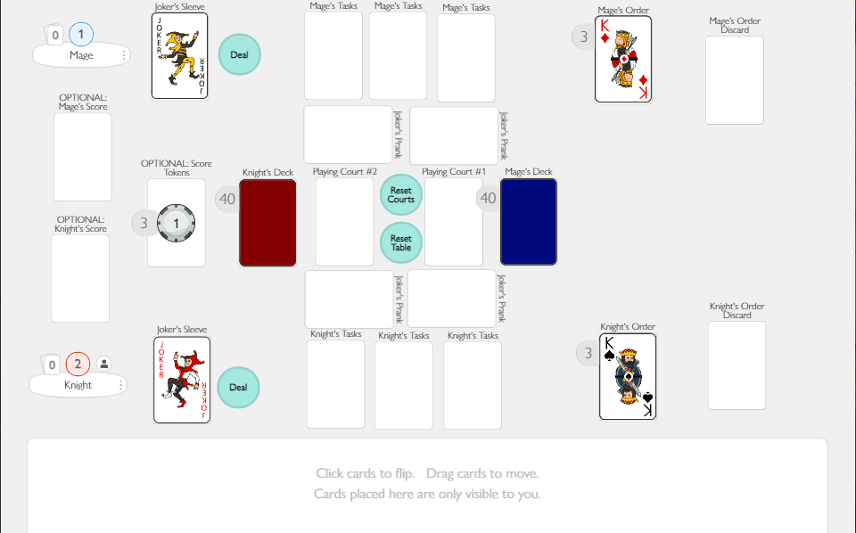

# Filling your Hands

1. 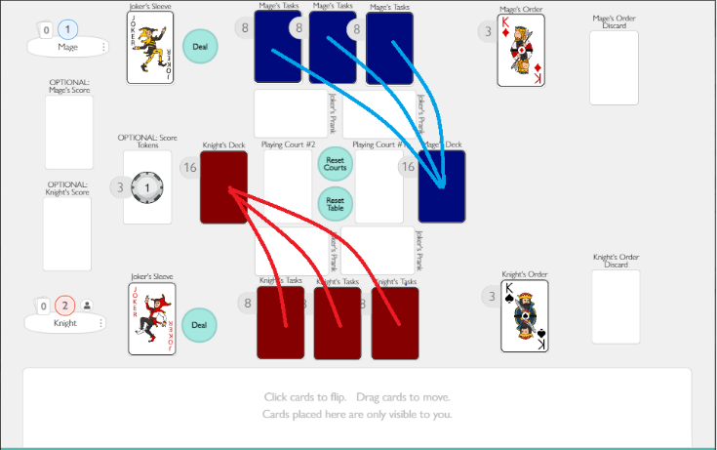Set up the table as shown in the picture above
   1. Remove all face cards (not Aces) and Jokers from two decks, saving one King, Queen, Jack, and Joker for each deck (total of two Kings, two Queens, two Jacks, and two Jokers)
   2. One joker per **Joker’s Sleeve**
   3. King, Queen, and Jack in each **Order** deck.
   4. Place one deck in **Knight’s Deck** and one deck in **Mage’s Deck**.
2. **Deal** 8 cards from your **Deck** into each of your **Task Decks** (total of 24 cards), leaving 16 cards in each **Deck**.

# Assigning Order

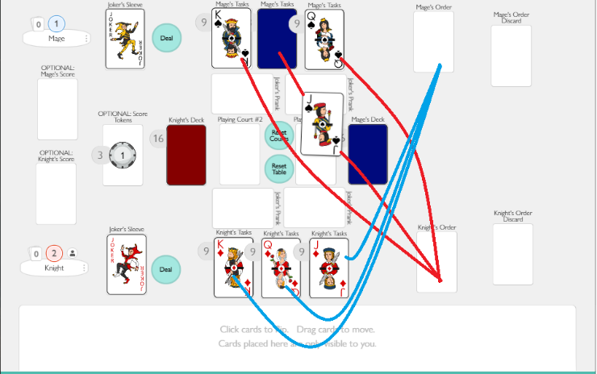What is **Order**? **Order** determines the order in which a player must clear their three **Task Decks**. The **Task Deck** with the Jack placed on top will be the first task deck cleared, the Queen the second, and King the third.

1. Flip the top cards of your Task decks over. Once both players have seen the top card for each **Task Deck** on the table, flip the top cards back over.
2. Place the cards in your **Order** holder (right side of the board) in the opposing player’s task decks, face up, assigning their **Order**.

# How to Play

All **bolded terms** refer to a spot / item on the playing table.

1. Complete the steps outlined in *“Filling Your Hands”* and *“Assigning Order”.*
2. Pull the task deck with the Jack card placed on top into your hand and remove the **Order** (face card) from the hand into your **Order Discard** holder. 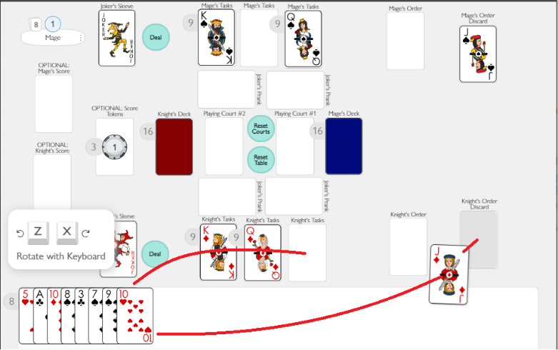
3. Place a card facedown from your **Deck** pile into the **Playing Court** immediately adjacent. When both players are ready, click the card you placed into **the Playing Court** to flip it over.

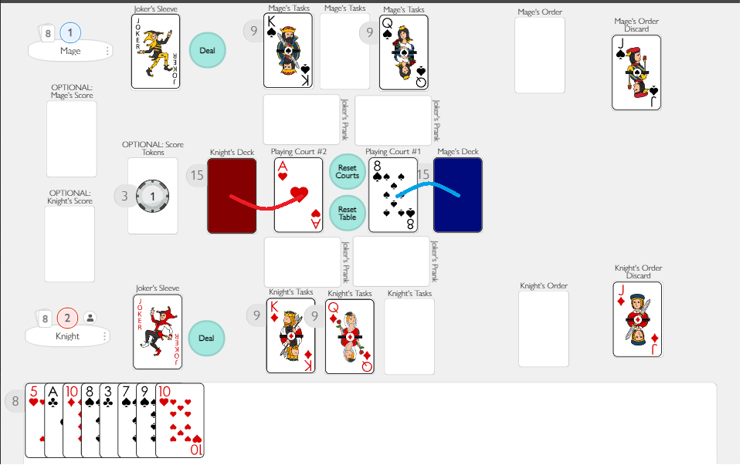

1. 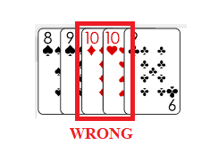Both players now work to clear the cards in their hand by counting either up or down from the top cards within the **Playing Courts**
   1. Players can play on either court (an exception to this rule will be explained later)
   2. Suit / Color of the card does not matter, only the number
   3. No repeating numbers on one Playing Court (i.e. 10 on 10)
   4. 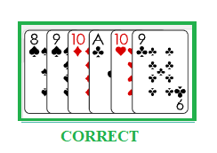Ace loops back to 2; 2 loops up to Ace.
      1. (ex. 9 -> 10 -> Ace -> 2 -> Ace -> 10 -> 9)
   5. Both players are trying to get their card on top of the Playing Court faster than the other player.
   6. If both players go to place a card on the same Playing Court, whichever card was there first stays and the other is returned to its player’s hand.
2. If neither player can place cards in the **Playing Court**s, repeat steps 3-4 again.
3. If one **Deck** runs out of cards, both the players pause, a player goes to **Reset Courts**, and game starts up again from Step 3.
   1. To **Reset Courts** is when you take all the cards in the Playing Courts, shuffle them together, and separate them evenly across the **Decks**.
4. The first player to clear their hand has gained a point (can be shown on the board with the poker token) and must enact the **Joker’s Prank!**
   1. See “*What is the Joker’s Prank”*section at the bottom.
5. Once one player has cleared all the cards in their hand, the end of the round has arrived!
   1. The player who cleared their hand must enact the **Joker’s Prank** on themselves (See “What is the Joker’s Prank?” section).
   2. The player who still has cards in their hands goes to **Reset Courts**.
   3. Each player then pulls the next task list into their hand and repeat steps 3-4 again until one player doesn’t have any more cards in any of their three task decks.

*CLARIFICATION*: The “loser” of the round will have both the left-over cards from their last task deck and the cards of their new task deck in their hand, but the “winner” of the round can only play on one of the **Playing Courts.** (Further explanation provided in “*What is the Joker’s Prank*” section)

# How to Win

The person who clears all the cards from their **Task Decks** wins!

To play again, **Reset** the **Table** and start from Step 1.

***Reset Table*** *is when all cards are returned to the Decks (make sure to separate the two playing card decks from one another)*

# What is the Joker’s Prank?

The Joker’s Prank is when your Joker is placed within either **Joker’s Pranks** on your side of the board (bottom of the board for Knight, top of the board for Mage).

When a **Joker’s Prank** is active, the person being blocked CANNOT place any cards on that associated Playing Court until the **Joker’s Prank** has been removed. (Example: If the Knight’s Joker’s Prank is on the right side of the board, they cannot place cards in Playing Court #1 until the block has been removed)

Only one **Joker’s Prank** can be active on the board! Whenever a new block is introduced on either side of the board, if there are any existing blocks, they must be removed to their **Joker’s Sleeve**.

If a player gets two **Joker’s Pranks** in a row, they cannot keep the Joker blocking the same Playing Court and must move it to the other block spot. (Example: If the Knight had an active block on the right side of the board and received another block, they must move the Joker to the left block spot).